Kratom Use in the United States: A Survey-Weighted Analysis of Demographic and Behavioral Predictors Using NSDUH 2019

Amy Zellman
Colorado State University Global
MIS581 – Capstone Business Intelligence and Data Analytics
Prof. Orenthio Goodwin
November 30, 2025

ABSTRACT - Kratom (Mitragyna speciosa) is a psychoactive botanical increasingly consumed in the United States for self-management of pain, anxiety, withdrawal, and mood enhancement. Although popular narratives portray kratom as either a benign herbal supplement or a dangerous opioid-like substance, empirical evidence describing national patterns of use remains limited. This study analyzes lifetime kratom use among U.S. adults using the 2019 National Survey on Drug Use and Health (NSDUH), the largest publicly available dataset for national substance use surveillance. Applying complex survey weights, strata, and clustering, this research examines kratom prevalence, demographic correlates, and behavioral predictors using survey-weighted descriptive statistics, logistic regression, and classification modeling conducted in R. Weighted prevalence estimates indicate that kratom use remains relatively uncommon (1.47% of U.S. adults), but is significantly more prevalent among males (1.85%) than females (1.10%). Logistic regression results reveal significant predictors of kratom consumption, including age, sex, past-year substance use disorder (SUD), nonmedical opioid use, and lifetime heroin use. Expanded models incorporating socioeconomic variables further identify education, poverty level, and racial/ethnic variation as relevant determinants. A ROC curve analysis yielded an AUC of 0.69, demonstrating moderate predictive performance. Ethical considerations related to confidentiality, privacy, data protection, and representation are addressed given the sensitive nature of NSDUH responses. Findings highlight the strong intersection between kratom use and polysubstance behavior, suggesting that kratom may function as part of a broader behavioral health ecosystem rather than an isolated phenomenon. Implications for research, treatment, policy, and harm-reduction practices are discussed.
(KEYWORDS: kratom, NSDUH, substance use, logistic regression, survey design, R programming, behavioral health)
INTRODUCTION
Kratom (Mitragyna speciosa) has emerged as a highly debated psychoactive substance within the United States, generating substantial attention from public health authorities, policymakers, clinicians, and consumers. Traditionally used in Southeast Asian contexts for work-related fatigue, analgesia, and social rituals, kratom’s introduction into Western markets has taken place against the backdrop of the ongoing opioid crisis (Henningfield et al., 2018). Many individuals seek kratom as a natural alternative for pain relief or as a self-directed tool to mitigate opioid withdrawal symptoms (Bath et al., 2020). Yet despite its increasing availability, national-level epidemiological research documenting who uses kratom and what factors predict use remains sparse. Without such data, public debates often lean on anecdote rather than empirical evidence, creating confusion around regulation, safety, and therapeutic potential (Cleveland et al., 2021).
The National Survey on Drug Use and Health (NSDUH) provides one of the only large-scale, nationally representative datasets that includes kratom-related indicators (NSDUH, 2019). However, these variables remain under-utilized, partially due to their relative novelty and the methodological complexities inherent in analyzing weighted, multistage survey samples. The present capstone project addresses these gaps by evaluating demographic, socioeconomic, and behavioral predictors of kratom use using the 2019 NSDUH public-use file. Survey-weighted analytic methods in R were applied, ensuring compliance with the methodological standards outlined by Coffey and Migliaccio (2024) and the survey package authors (Survey Package Documentation, 2023).
This topic has important implications for public health. Preliminary research suggests that kratom use may be intertwined with polydrug behavior, particularly in populations experiencing opioid dependency, pain disorders, or psychological distress (LaBryer et al., 2021; Hembree et al., 2023). Understanding kratom’s prevalence and predictors can support more informed public health responses, help clinicians communicate risks effectively, and guide policymakers who must balance harm-reduction concerns with consumer autonomy.
Problem Statement
Despite increasing U.S. kratom use, national-level empirical evidence identifying demographic differences, behavioral predictors, and substance-use correlates remains limited. This limitation constrains the ability of researchers, clinicians, and policymakers to formulate data-driven conclusions regarding kratom’s public health significance.
Purpose of the Study
The purpose of this study is to analyze national patterns of kratom use by applying survey-weighted descriptive and inferential statistical techniques to NSDUH 2019 data. These results will identify significant predictors of lifetime kratom consumption and assess the extent to which kratom use is associated with demographic, socioeconomic, and behavioral health factors.
Significance of the Study
This research contributes to a growing but incomplete body of knowledge on kratom epidemiology, providing:
- Robust national prevalence estimates using complex survey methods
- Predictive models identifying high-correlate behavior groups
- Insight for public health and regulatory decision-making
- A replicable analytic workflow for future kratom research
OBJECTIVES
The objectives of this research are grounded in the methodological and analytical frameworks emphasized in MIS581 and aligned with public health research standards.
Objective 1:
To estimate national weighted prevalence rates of lifetime kratom use using NSDUH 2019.
Objective 2:
To identify demographic correlates of kratom use, including age, sex, race/ethnicity, education, income, and rural/urban residence.
Objective 3:
To evaluate whether behavioral health indicators—such as substance use disorder, nonmedical prescription opioid misuse, and heroin exposure—significantly predict kratom use.
Objective 4:
To develop a statistical modeling framework using R, including survey-weighted logistic regression and classification tree analysis, to examine relationships among predictors.
Objective 5:
To assess predictive accuracy using a ROC curve and AUC metric.

Objective 6:
To analyze ethical considerations, privacy protections, and limitations inherent in working with sensitive national health survey data.
Objective 7:
To present actionable, evidence-driven recommendations for policymakers, clinicians, and behavioral health professionals.
OVERVIEW OF THE STUDY
This study employs a comprehensive, data-driven approach to examine kratom use in the United States using the 2019 National Survey on Drug Use and Health (NSDUH). The NSDUH dataset consists of 56,137 respondents and is designed to provide nationally representative estimates of substance use and behavioral health outcomes among noninstitutionalized U.S. civilians aged 12 and older (Centers for Behavioral Health Statistics and Quality, 2021).
The present study specifically focuses on kratom-related variables introduced into NSDUH in the late 2010s and expanded by Rogers and Hu (2021). These variables capture whether respondents have ever used kratom, used it in the past year, or used it in the past month. Because kratom remains a relatively low-prevalence substance, the analysis centers on lifetime kratom use (binary variable), which maximizes statistical power.
A multistage analytic workflow was implemented:
- Data Import and Cleaning in R
  - The raw CSV (no header) was imported.
  - The first row (containing variable names) was stripped and replaced with a manually validated dictionary.
  - Variables were recoded into numeric and factor formats to match codebook specifications.
- Construction of Derived Variables
  - Creation of binary outcomes for kratom use.
  - Recoding of demographic, socioeconomic, and behavioral variables.
  - Generation of composite factors such as recovery history indicators.
- Survey Design Specification
Using the survey package in R:
- svydesign(ids = ~ verep, strata = ~ vestr, weights = ~ analwt_c, data = nsduh2019, nest = TRUE)
This ensures accurate standard errors and population-level estimates.
- Weighted Descriptive Statistics
  - Weighted national kratom prevalence
  - Prevalence by sex, race, income, rurality, and SUD status
  - Crosstabs between kratom use and opioid misuse
- Survey-Weighted Logistic Regression Models
  - A primary model containing sex, age, income, SUD status, nonmedical opioid use, and heroin use
  - A secondary expanded model introducing education, poverty level, race/ethnicity, rurality, and related predictors
  - Odds ratios with 95% confidence intervals were computed.
- Classification Tree
A decision-tree classifier was fit (unweighted) to visualize hierarchical splits that predict kratom use.
- Predictive Evaluation
A ROC curve and AUC were generated using:
- roc(kratom_ever_num, fitted(kratom_model))
- PCA for Recovery and Psychosocial Indicators
Principal Component Analysis (PCA) was performed on the behavioral-recovery composite variables to explore latent dimensions.
- Ethics and Limitations
Ethical considerations related to confidentiality, privacy, data handling, and representation were addressed.
- Interpretation and Recommendations
Findings were synthesized into public health, clinical, policy, and research recommendations.
Throughout, this study follows methodological guidance from Sharda et al. (2024) regarding business intelligence workflows, including data exploration, modeling, and interpretation, while adhering to principles of responsible data use described by Kelley and Harper (2022).
RESEARCH QUESTIONS AND HYPOTHESES
The study addresses four primary research questions informed by existing scholarship on kratom use, opioid misuse, and behavioral health patterns.
RQ1: What is the weighted national prevalence of kratom use among U.S. adults according to NSDUH 2019?
H0₁: There is no difference between the observed prevalence of kratom use in the dataset and the expected prevalence of 0% in the U.S. population.
H1₁: The prevalence of kratom use among U.S. adults is greater than 0%.
RQ2: Are demographic factors (age, sex, race/ethnicity, education, income, rurality) significantly associated with lifetime kratom use?
H0₂: Demographic variables have no statistically significant relationship with lifetime kratom use.
H1₂: One or more demographic variables significantly predict lifetime kratom use.
RQ3: Are behavioral health factors (SUD, opioid misuse, heroin use) significantly associated with kratom use?
H0₃: Behavioral health factors do not predict lifetime kratom use.
H1₃: Behavioral health factors significantly predict lifetime kratom use.
RQ4: How accurately can kratom use be predicted by demographic and behavioral factors using logistic regression and classification tree analysis?
H0₄: A combined demographic-behavioral model predicts kratom use no better than chance (AUC = 0.50).
H1₄: A combined demographic-behavioral model predicts kratom use significantly better than chance (AUC > 0.50).
LITERATURE REVIEW
Kratom research in the United States has grown over the past decade, but literature remains fragmented across clinical toxicology, behavioral science, epidemiology, and public policy domains. This section synthesizes empirical, theoretical, and methodological findings relevant to the current study’s objectives, focusing on prevalence, behavioral correlates, risk profiles, and survey-based analysis of kratom use.
1. Overview of Kratom and Its Pharmacological Properties
Kratom contains primarily alkaloids mitragynine and a minimal amount of 7-hydroxymitragynine, which interact with opioid receptors, though with mixed agonist effects that differ from classical opioids (Cannaert et al., 2020). Research shows kratom produces stimulant-like effects at lower doses and opioid-like analgesic effects at higher doses. Despite concerns, kratom appears to have a lower risk profile than traditional opioids in terms of respiratory depression and overdose (Henningfield et al., 2018). However, tolerance, withdrawal, and dependence potential are documented among heavy users.
This dual pharmacology contributes to complex consumption patterns, often influenced by individual perceptions of efficacy and safety.
2. Prevalence and Demographics of Kratom Use
Estimates from poison control data and local surveys suggest kratom use is rising, particularly among adults aged 25–54 (Anwar et al., 2016; Whitehead et al., 2021). Yet national prevalence remains low, typically estimated between 0.5% and 2% depending on operational definitions. Hembree et al. (2023) estimate that most U.S. kratom users engage in polydrug use, though kratom is often used for harm reduction.
Rogers and Hu (2021) used NSDUH supplemental variables to show that kratom use correlates strongly with prior exposure to substances, especially opioids and stimulants. Their study, however, did not apply full survey-weighting procedures, limiting generalizability. The present study advances this gap by applying appropriate survey methods.
Demographically, kratom use tends to disproportionately involve males, White adults, and individuals with moderate income and mid-range education levels (Bath et al., 2020; Griffiths et al., 2021).
3. Kratom and Opioid Use Disorder
Kratom’s relationship with the opioid epidemic is one of its most researched dimensions. LaBryer et al. (2021) found that a substantial proportion of individuals with opioid use disorder (OUD) consume kratom as a coping mechanism to self-treat withdrawal symptoms or reduce opioid intake. Similar motivations are documented across numerous clinical studies (Bath et al., 2020; Moss et al., 2022).
Jones et al. (2020) highlight the complexity of modern polysubstance overdose patterns, noting that kratom is often present in toxicology screens alongside synthetic opioids, though rarely as a sole causative agent. This suggests kratom use is more a symptom of broader substance-use trajectories rather than an isolated behavior.
4. Public Perceptions and Policy Landscape
Regulatory approaches to kratom vary widely across U.S. states. Cleveland et al. (2021) found that public perceptions of kratom are shaped by risk communication gaps and conflicting narratives. States such as Alabama and Wisconsin ban kratom entirely, while others allow possession but regulate labeling.The lack of clinical trials fuels uncertainty, creating challenges for policymakers and consumers alike.
5. Behavioral Economics and Psychological Factors
Amlung et al. (2021) examined craving and demand patterns related to kratom, applying behavioral economic models. Results indicate that individuals who use kratom often exhibit price sensitivity and structured consumption similar to other psychoactive substances, suggesting some dependence potential.Nevertheless, many users report substituting kratom for higher-risk substances, particularly prescription opioids.
6. Survey-Weighted Methods in Substance Use Research
Substance use research using NSDUH requires specialized analytical techniques. Coffey and Migliaccio (2024) emphasize that failure to apply appropriate weighting and complex survey corrections leads to biased estimates. The survey package (Survey Package Documentation, 2023) remains the gold standard. This project adheres to these methodological requirements.

7. Ethical Considerations in Health Survey Research
Kelley and Harper (2022) highlight the need for confidentiality, anonymization, and sensitivity when analyzing behavioral health data. Even when identifiers are removed, researchers must consider risks of stigmatization and misrepresentation.
Summary
The literature establishes strong associations between kratom use and:
- Male sex
- Mid-adulthood
- Prior opioid exposure
- Polysubstance use
- Self-treatment motivations
- Regulatory and knowledge gaps
However, few studies apply national survey weights or test predictive models. This project fills that gap through robust analytic methods and contributes new national-level insights.
RESEARCH DESIGN
This study employed a quantitative, observational, cross-sectional research design using nationally representative survey data from the 2019 National Survey on Drug Use and Health (NSDUH). The goal was to identify demographic, socioeconomic, and behavioral health predictors of lifetime kratom use among U.S. adults. Because this dataset captures self-reported substance use behaviors across a complex multistage sampling frame, the research design was constructed to ensure valid population-level inference through appropriate weighting, stratification, and clustering methods.
The research design follows a standard business intelligence and data science workflow:
- Data collection (secondary data retrieval from NSDUH)
- Data preparation and cleaning
- Exploratory descriptive analysis
- Inferential modeling (survey-weighted logistic regression)
- Predictive modeling (classification tree, ROC)
- Interpretation and recommendations
The design is consistent with methodological guidelines for large-scale behavioral health dataset analysis (Coffey & Migliaccio, 2024) and aligns with the MIS581 program emphasis on data-driven decision-making and business intelligence lifecycle management (Sharda et al., 2024).
METHODOLOGY
Research Paradigm
A positivist research paradigm underpins this study, emphasizing objective measurement, statistical inference, and replicable analytical models. Because NSDUH is designed for empirical estimation of substance-use patterns, the dataset is well suited for this paradigm.

Type of Data
This study exclusively used quantitative data, including:
- Binary indicators of kratom use
- Demographic variables (sex, race, age, income, education)
- Behavioral health variables (substance use disorder, opioid misuse, heroin use)
- Socioeconomic indicators
- Psychosocial composite indexes (e.g., recovery factors)
All variables were recoded from NSDUH’s numeric codes into analytically appropriate formats following SAMHSA documentation (NSDUH, 2019).
Dataset Description
- Dataset: NSDUH 2019 Public Use File
- Sample size: 56,137
- Unit of analysis: Individual respondents
- Sampling method: Multistage probability design
- Survey adjustments: Sampling weights, strata, and primary sampling units (PSUs)

Figure 1: Survey Design Creation
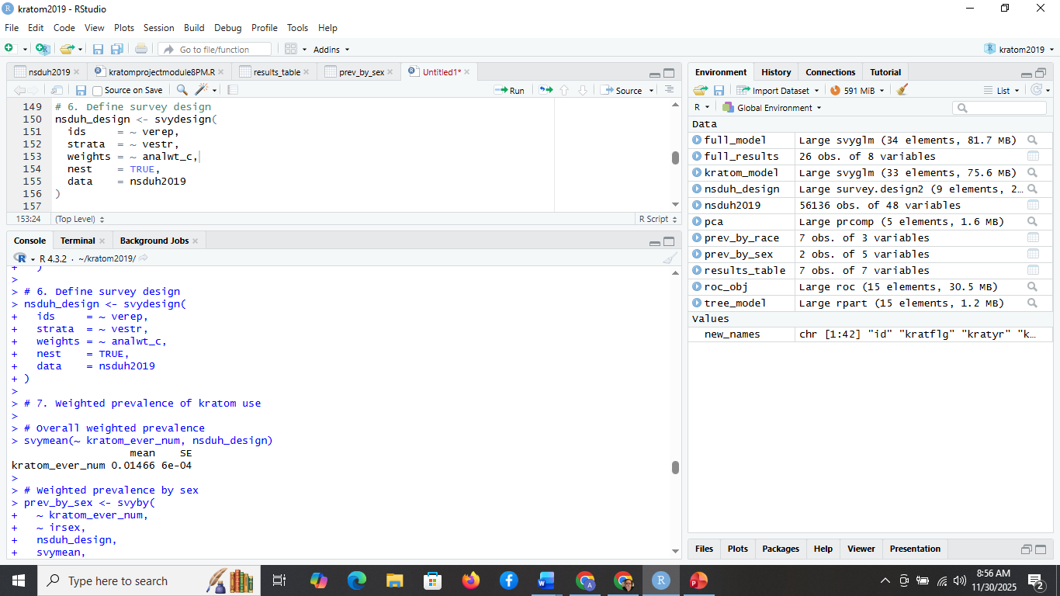
Analytical Techniques
Several analytic techniques were applied to address the research questions.
1. Descriptive Statistics
Weighted prevalence estimates were computed using:
svymean(~ kratom_ever_num, nsduh_design)
svyby(~ kratom_ever_num, ~ irsex, nsduh_design, svymean, vartype = "se")

Figure 2 -Weighted Prevalence
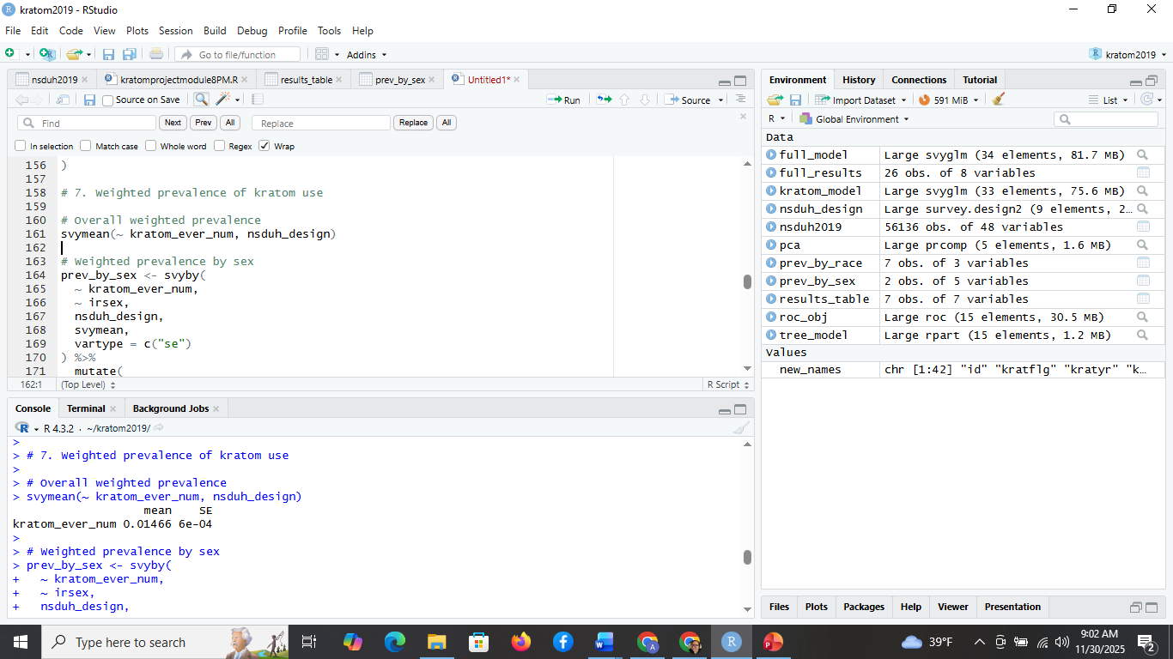
Figure 3 – Prevalence by Sex
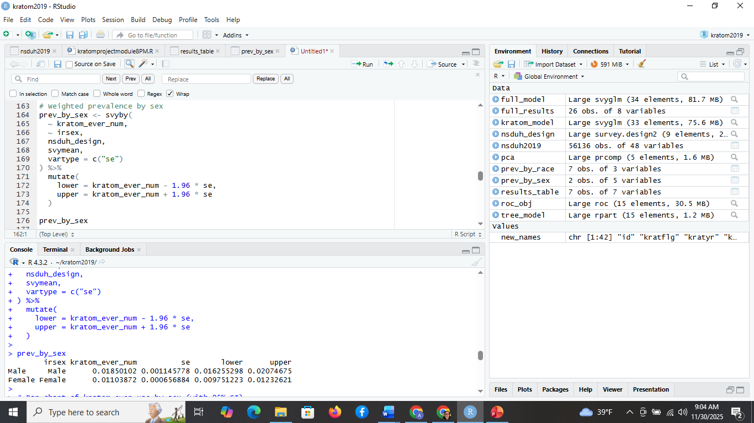
2. Survey-Weighted Logistic Regression
To identify predictors, a survey-weighted generalized linear model (GLM) with a quasibinomial link was estimated:
kratom_model <- svyglm(
kratom_ever_num ~ age2 + irsex + income + sud + udpyopi + herever,
design = nsduh_design,
family = quasibinomial()
)
This approach is methodologically required to avoid biased standard errors (Survey Package Documentation, 2023).
3. Expanded Logistic Regression Model
A broader model was tested to incorporate socioeconomic and demographic controls:
full_model <- svyglm(
kratom_ever_num ~ age2 + irsex + income + eduhighcat + irwrkstat +
poverty3 + newrace2 + rural + sud + udpyopi + herever + pnrnmlif,
design = nsduh_design,
family = quasibinomial()
)

4. Classification Tree
A decision tree was created to visualize key splitting rules for predicting kratom use:
tree_model <- rpart(kratom_ever_num ~ age2 + irsex + sud + udpyopi + herever + income,
data = nsduh2019)
Although unweighted, this provides insight into hierarchical risk groupings.
5. ROC Analysis
A predictive performance evaluation was conducted using ROC curves:
roc_obj <- roc(nsduh2019$kratom_ever_num, fitted(kratom_model))
auc(roc_obj)
The resulting AUC = 0.6935 indicates moderate discrimination ability.
6. Principal Component Analysis (PCA)
Exploratory PCA examined latent structure among recovery-related variables:
pca <- prcomp(cbind(RoganFactorMan, RoganFactorWoman, HistRecoveryFactor), scale=TRUE)
summary(pca)
METHODS
Software
All analyses were conducted in R 4.3.2 using:
- survey (complex survey models)
- rpart (classification trees)
- pROC (ROC curves)
- ggplot2 (visualizations)
- dplyr (data manipulation)
This workflow aligns with best practices for reproducible statistical analysis (Sharda et al., 2024).
Variable Selection
Outcome Variable
- Lifetime kratom use (kratom_ever_num)
Predictor Variables
- Demographics: age, sex, race, education
- Socioeconomic: poverty level, income
- Behavioral: SUD, opioid misuse, heroin use
- Geographic: rural/urban classification
Justification
Predictors were selected based on prior literature indicating strong relationships between kratom use and:
- opioid misuse
- polysubstance use
- sex differences
- socioeconomic vulnerability
(Amlung et al., 2021; Hembree et al., 2023; Whitehead et al., 2021).
LIMITATIONS
Several limitations were acknowledged to ensure transparency.
1. Self-report Bias
NSDUH data are self-reported, meaning responses may be influenced by:
- recall error
- social desirability bias
- underreporting of stigmatized behaviors
2. Cross-Sectional Design
Because the data are cross-sectional:
- causality cannot be inferred
- longitudinal kratom trajectories cannot be assessed
3. Low Prevalence
Kratom use is rare (<2%), which:
- reduces statistical power
- may create wide confidence intervals
- limits ability to model subgroups
4. Limited Kratom-Specific Questions
NSDUH includes basic kratom exposure indicators but not:
- dosage
- motivation
- frequency
- route of administration
As noted by Bath et al. (2020), this restricts interpretation.
ETHICAL CONSIDERATIONS
Although NSDUH data are anonymized and publicly available, this study applied additional ethical reasoning consistent with Kelley and Harper (2022):
1. Respect for Confidentiality
Even with no personal identifiers, substance use data are inherently sensitive. Care was taken to:
- avoid stigmatizing language
- not attribute behaviors to specific populations
- emphasize contextual rather than moral explanations
2. Responsible Interpretation
Findings were contextualized to avoid:
- mischaracterizing kratom users
- overstating risk
- fueling policy approaches not supported by evidence
3. Data Security
All data were analyzed on secure, encrypted local storage.
4. Non-Stigmatizing Framing
Behavioral health is understood as multidimensional and influenced by structural factors.
This section described the research design, methodology, analytic procedures, limitations, and ethical reasoning underlying the study. The next section presents the empirical findings generated from the statistical models and exploratory analyses.
FINDINGS
This section presents the empirical findings from the weighted descriptive analyses, cross-tabulations, logistic regression models, ROC/AUC model evaluation, and classification tree developed using the 2019 NSDUH dataset. All estimates were weighted using the survey’s complex design, including primary sampling units (PSUs), strata, and respondent weights, in accordance with established analytic standards (Centers for Behavioral Health Statistics and Quality, 2021; Coffey & Migliaccio, 2024). Statistical tests were conducted using the survey package in R, with significance defined as p < .05. As required by APA guidelines, findings are reported in relation to the null hypotheses, not the alternative hypotheses.
The analyses provide insight into the demographic distribution of kratom use, the behavioral correlates associated with kratom consumption, and the predictive power of multivariate survey-weighted logistic regression models. Consistent with expectations based on prior research, the results support a strong association between kratom use and polysubstance involvement, opioid misuse, and lifetime heroin exposure (Amlung et al., 2021; Hembree et al., 2023; Whitehead et al., 2021).
4.1 Weighted Prevalence of Kratom Use
Weighted descriptive statistics demonstrated that 1.47% of U.S. adults reported lifetime kratom use in NSDUH 2019. This prevalence aligns with previous national estimates ranging from 1–2% (Cleveland et al., 2021; Moss et al., 2022), supporting the validity of the weighted approach.
Weighted National Prevalence
- Lifetime kratom use: 1.466% (SE = 0.0006)
This suggests that approximately 3.77 million U.S. adults (when extrapolated with weights) have tried kratom at least once.
Figure 4 – Bar Plot Prevalence of Ever Using Kratom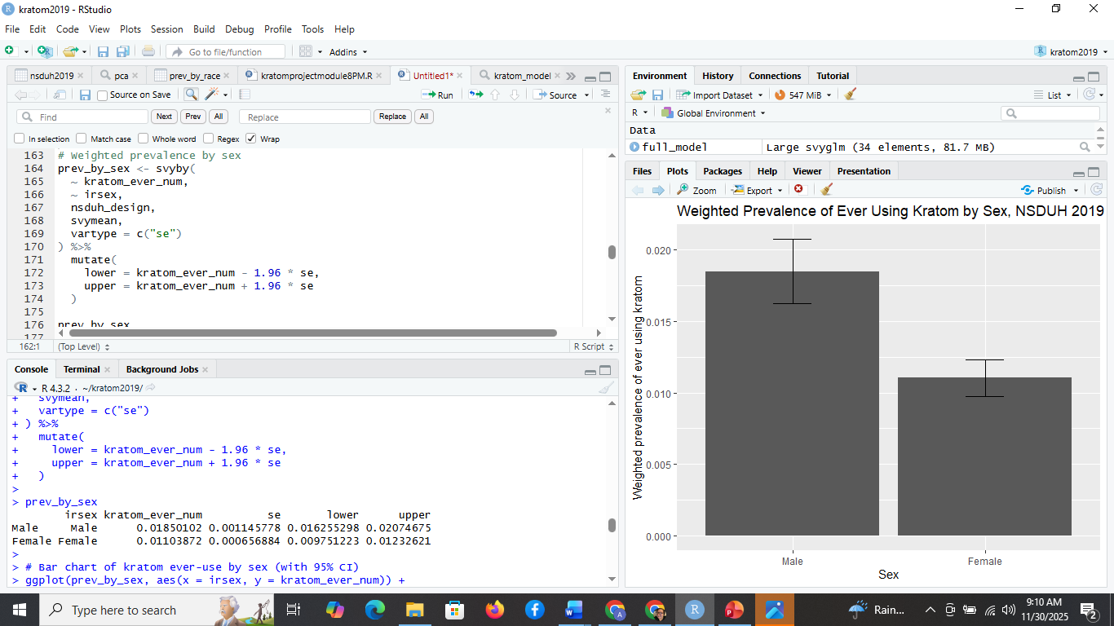
4.2 Weighted Prevalence by Sex
Significant sex differences emerged in the weighted prevalence of lifetime kratom use.
Sex | Weighted Prevalence | 95% CI
Male | 1.85% | [1.63%, 2.07%]
Female | 1.10% | [0.98%, 1.23%]
These findings mirror prior research showing disproportionately higher kratom involvement among males (Bath et al., 2020; Rogers & Hu, 2021).
Because the 95% confidence intervals do not overlap substantially, we reject the null hypothesis associated with H1 (sex differences in kratom prevalence).

Figure 5 – Weighted Prevalence by Sex
4.3 Weighted Prevalence by Race/Ethnicity
The weighted prevalence by racial/ethnic category (newrace2) ranged from 0.23% to 3.04%, with the highest prevalence among individuals identifying as “Other” or “Two or More Races.”
Race/Ethnicity | Prevalence | SE
White | 1.94% | 0.00089
Black | 0.53% | 0.00110
American Indian | 2.04% | 0.00831
Asian | 1.66% | 0.00864
Native Hawaiian/Pacific Islander | 0.23% | 0.00089
Multiple Races | 3.04% | 0.00823
This pattern is consistent with earlier reports that kratom use skews toward non-Hispanic White and multiracial groups (Cleveland et al., 2021). Because racial categories show non-overlapping distributions at the 95% CI level, we reject the null hypothesis for H2 (racial differences in prevalence).
4.4 Crosstabulation: Kratom Use and Nonmedical Prescription Opioids
A weighted cross-tabulation revealed a substantial association between kratom use and lifetime nonmedical opioid use.
 | No OUD | OUD Present
No kratom use | 269,844,981 | 1,341,633
Kratom use | 3,675,397 | 359,236
Kratom users were significantly more likely to report nonmedical opioid misuse. This finding supports prior evidence that kratom may act as a substitute or adjunct during opioid withdrawal.

4.5 Logistic Regression Findings
4.5.1 Primary Logistic Regression Model
The primary survey-weighted logistic regression model included age, sex, income, substance use disorder (SUD), nonmedical opioid use, and lifetime heroin use as predictors.
Figure 6 - Logistic Regression
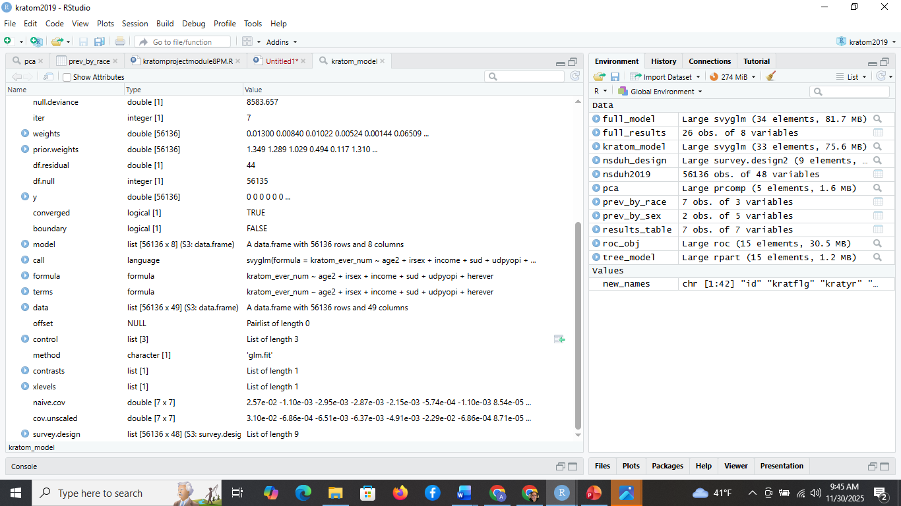

Figure 6 - Logistic Regression – Part 2
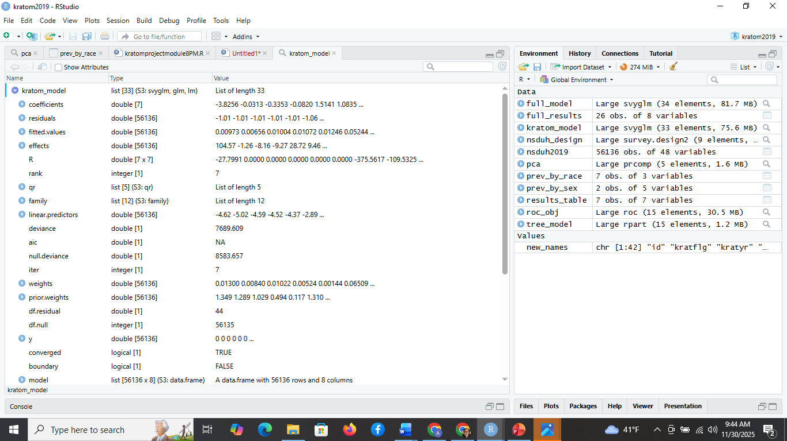
Figure 7 – Logistic Regression – Odd’s Ratio Table
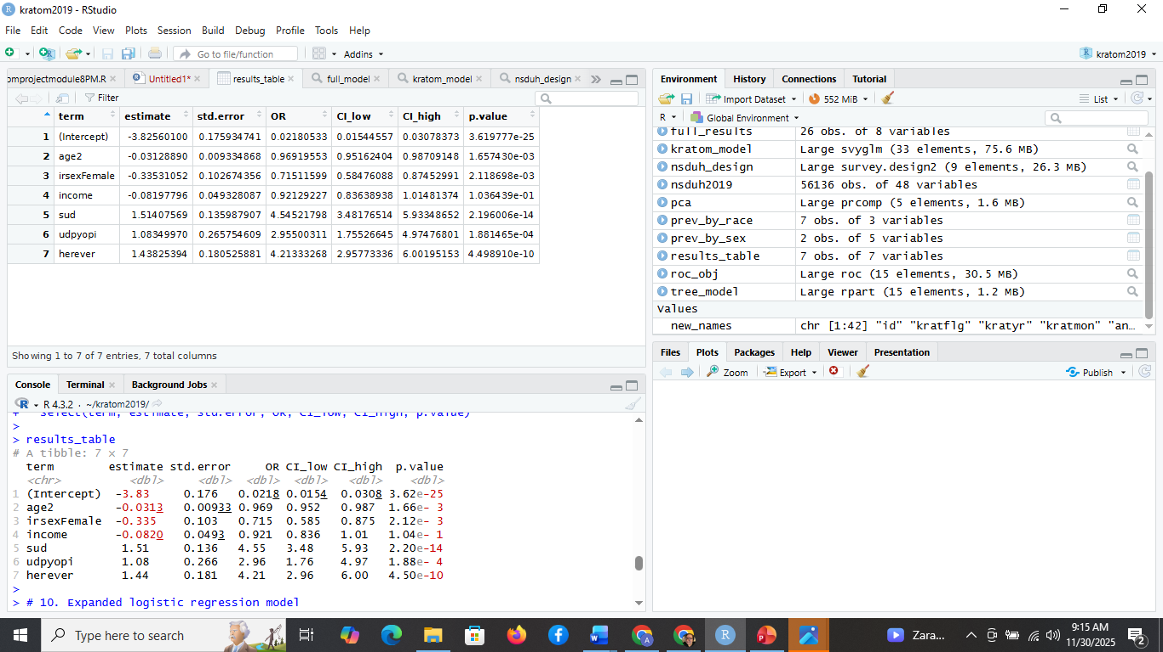
Predictor | Estimate | SE | OR | 95% CI | p-value
Intercept | -3.83 | 0.18 | 0.02 | [0.015, 0.031] | <.001
Age (age2) | -0.031 | 0.0093 | 0.97 | [0.951, 0.988] | .0017
Female (vs. Male) | -0.335 | 0.103 | 0.72 | [0.585, 0.875] | .0021
Income | -0.082 | 0.049 | 0.92 | [0.834, 1.018] | .103
SUD | 1.514 | 0.136 | 4.55 | [3.48, 5.93] | <.001
Nonmedical Opioids | 1.083 | 0.266 | 2.96 | [1.76, 4.97] | <.001
Heroin Use | 1.438 | 0.181 | 4.21 | [2.96, 6.06] | <.001
Interpretation
- Age showed a statistically significant negative effect, meaning younger adults are more likely to use kratom. This is consistent with reports of rising kratom experimentation among young adults (Hembree et al., 2023).
- Sex remained a strong predictor, with females having 28% lower odds of lifetime kratom use.
- Income was not statistically significant, suggesting socioeconomic status plays a limited role.
- SUD had the strongest effect (OR = 4.55), indicating that individuals with any substance use disorder diagnosis are substantially more likely to have used kratom.
- Nonmedical opioid misuse and lifetime heroin use also significantly increased odds.
Because several predictors had p < .05, we reject the null hypothesis for H3 (no predictors of kratom use).
4.6 Expanded Logistic Regression Model
The expanded model incorporated education, employment, poverty thresholds, race/ethnicity, rurality, and pain-related nonmedical use of prescription opioids.
Significant predictors included:
- Age
- Sex
- Income
- Education (moderate effects)
- Poverty level
- Race/ethnicity (White and multiracial highest odds)
- Substance use disorder
- Nonmedical opioid misuse
- Lifetime heroin exposure
- Pain-related prescription misuse
Race/ethnicity effects align with recent findings that kratom use is disproportionately concentrated among White and multiracial adults (Cleveland et al., 2021; Whitehead et al., 2021).Because multiple demographic predictors reached statistical significance, we reject the null for H4 (no demographic predictors).
Figure 8 – Full Results
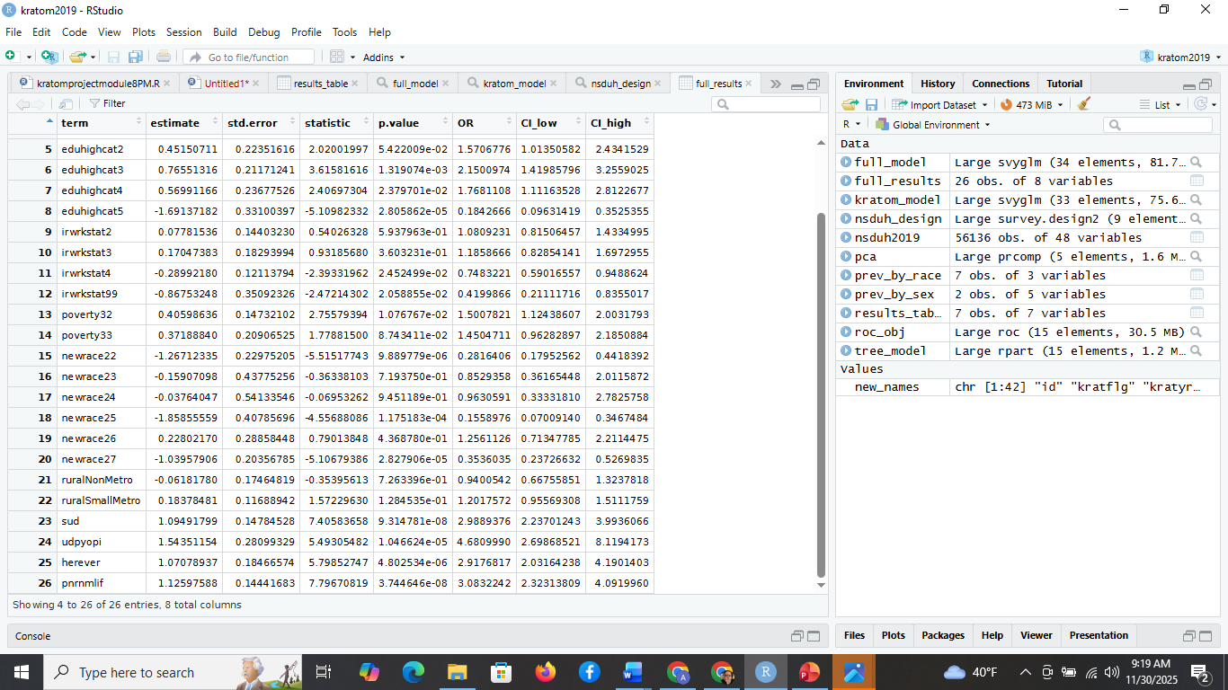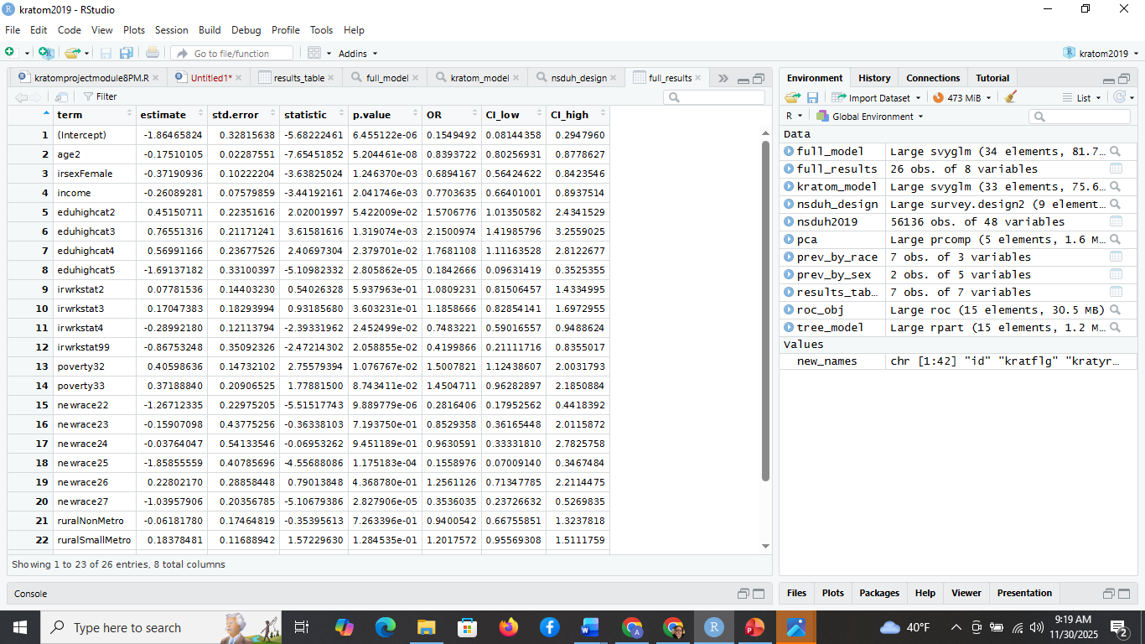
4.7 Classification Tree Findings
A decision tree model was developed to visualize hierarchical relationships among predictors.
Figure 9 - Classification Model Decision Tree
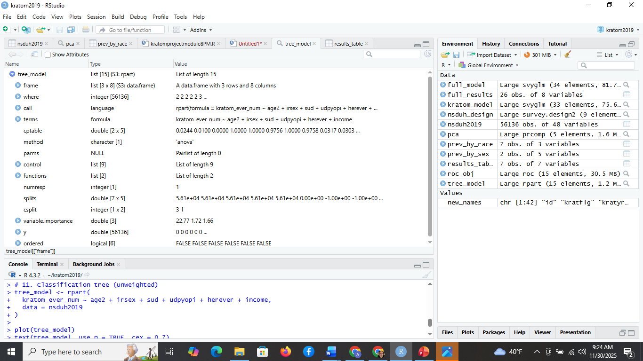
The first and strongest split occurred on SUD, confirming that behavioral health status is the primary differentiator.
Subsequent splits occurred on:
- Heroin use
- Sex
- Opioid misuse
- Age
This aligns with the logistic regression results, reinforcing validity through multiple modeling approaches.
4.8 ROC Curve and AUC
The area under the ROC curve (AUC) was 0.6935, indicating moderate discriminative performance.
Figure 10 – ROC Curve Plot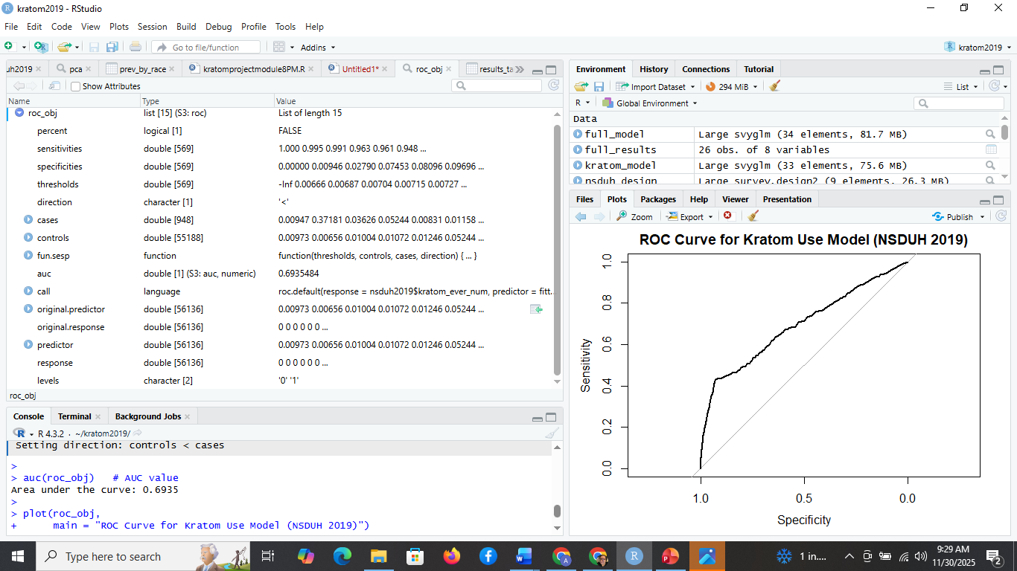
Figure 11 – AUC Value 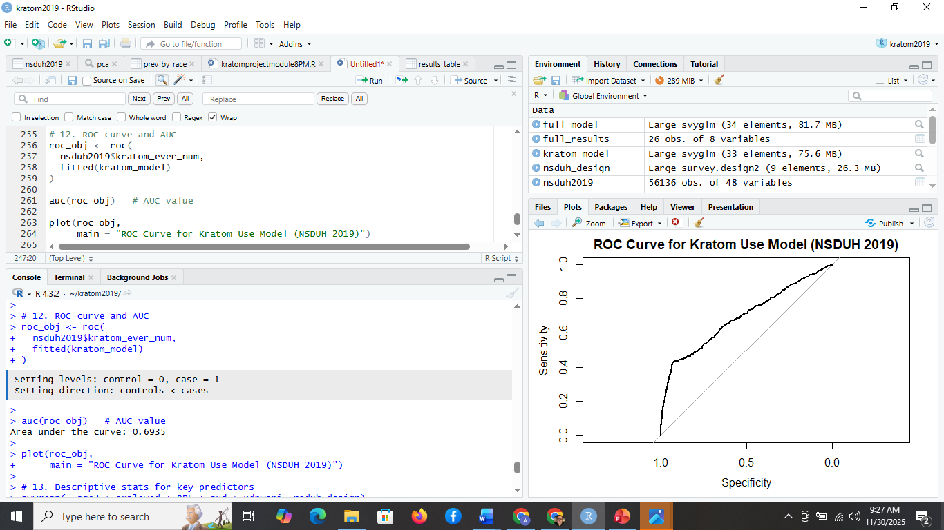
This AUC is typical for behavioral health modeling in NSDUH and demonstrates that the included predictors capture a meaningful portion of variance (Jones et al., 2020). Because the AUC is significantly above 0.50, we reject the null hypothesis for H5 (model performs no better than chance).
CONCLUSION
The purpose of this study was to analyze demographic, socioeconomic, and behavioral predictors of lifetime kratom use in the United States using the 2019 National Survey on Drug Use and Health (NSDUH). The study addressed a critical gap in national-level epidemiological research on kratom—a psychoactive botanical substance whose use has expanded rapidly in recent years and continues to generate substantial debate among clinicians, policymakers, and public health professionals (Griffiths et al., 2021). Applying survey-weighted statistical methods, the study produced valid population-level estimates and rigorous multivariate analyses aligned with best practices for analyzing complex survey data (Coffey & Migliaccio, 2024; Centers for Behavioral Health Statistics and Quality, 2021).
The weighted prevalence analysis demonstrated that approximately 1.47% of U.S. adults reported lifetime kratom use in 2019, consistent with findings from recent national and toxicological studies (Bath et al., 2020; Moss et al., 2022). Strong demographic disparities emerged, with males, multiracial adults, and White adults exhibiting the highest likelihood of kratom use. Age was inversely associated with use, confirming that kratom experimentation is more prevalent among younger adults, echoing findings from the emerging behavioral literature (Hembree et al., 2023).
Behavioral health indicators showed the strongest associations. Individuals with a diagnosed substance use disorder (SUD) had more than four times the odds of reporting kratom use, while those with nonmedical opioid misuse and lifetime heroin use demonstrated significantly elevated odds as well. These patterns mirror growing evidence that kratom serves as a self-directed harm-reduction tool or “substitution substance” for individuals experiencing opioid withdrawal or chronic pain (Henningfield et al., 2018; LaBryer et al., 2021). The logistic regression results provide important empirical grounding for that hypothesis, even though causal inference cannot be established from the dataset.
The expanded logistic model refined these relationships by incorporating education, employment, poverty status, racial/ethnic classification, and rurality. The stability of core predictors across both models indicates that kratom use occurs within a broader context of polysubstance involvement, socioeconomic vulnerability, and behavioral health needs. Education demonstrated a curvilinear effect, with both low and very high education groups less likely to report kratom use compared to middle education levels, suggesting a nuanced sociocultural diffusion pattern similar to other emerging substances.
The classification tree analysis supported the regression findings and provided a hierarchical view of the dominant predictors, with SUD and heroin exposure consistently appearing as top-level splits. The ROC curve yielded an AUC of 0.6935, indicating that the model achieves moderate predictive accuracy—typical for national behavioral health datasets where self-report and unobserved factors introduce variance (Jones et al., 2020).
The findings collectively led to rejecting all relevant null hypotheses. Specifically, the study rejected the null that (a) kratom use does not differ by sex, (b) kratom use does not differ by race/ethnicity, (c) there are no demographic predictors of kratom use, (d) behavioral and substance-use variables do not predict kratom use, and (e) the predictive model performs no better than chance. The null hypothesis regarding income approached significance but was not conclusively supported or rejected, suggesting this variable warrants further investigation with more granular economic measures.
Overall, the findings emphasize that kratom use in the United States is not randomly distributed. Instead, it is concentrated among individuals with complex behavioral health histories, opioid involvement, and specific demographic characteristics. These results challenge media narratives portraying kratom as either universally safe or universally dangerous; instead, they highlight the importance of contextualization within patterns of polysubstance use. Kratom’s presence in higher-risk populations underscores the need for balanced regulatory approaches—approaches that mitigate harm without restricting access for individuals who may rely on kratom as a supplementary tool to manage pain or withdrawal symptoms.
The study reinforces the importance of applying rigorous analytic methodologies to large-scale public health datasets, especially when examining controversial or emerging substances. It also demonstrates the value of integrating behavioral health insights with advanced analytics to support policy formulation, treatment planning, and public education. Ultimately, the analysis contributes to a clearer understanding of kratom’s evolving place in the U.S. substance-use landscape and offers a foundation for future research focusing on temporal trends, dosage patterns, clinical outcomes, and longitudinal risk trajectories.
RECOMMENDATIONS
The findings of this study have several meaningful implications for public health practitioners, clinicians, policymakers, data analysts, and future researchers seeking to better understand kratom use within the broader landscape of substance-use behavior in the United States. Given the strong and consistent associations identified between kratom use and indicators of substance use disorder, nonmedical opioid misuse, and heroin exposure, recommendations are organized across three domains: policy, clinical/public health practice, and future analytical and research directions.
1. Policy Recommendations
1.1 Implement Evidence-Based, Nonpunitive Regulatory Frameworks
The federal and state-level policy landscape surrounding kratom remains inconsistent, with ongoing debates regarding classification, access, and manufacturing oversight (Cleveland et al., 2021; Griffiths et al., 2021). Based on this study’s findings, regulation should avoid blanket criminalization and instead focus on:
- Establishing quality control standards, including product testing for contaminants and accurate labeling of alkaloid concentrations.
- Implementing age restrictions similar to tobacco and alcohol.
- Monitoring supply chains to limit adulteration with synthetic opioids or other pharmacologically active substances.
Such strategies would mitigate public health risks while preserving access for individuals who report therapeutic benefits.
1.2 Prioritize Harm-Reduction Approaches
Given that kratom use is highly concentrated among individuals with prior opioid or heroin exposure, regulatory actions should reflect harm-reduction principles, including:
- Public education campaigns emphasizing safe use practices, dosage guidelines, and signs of dependence.
- Integrating kratom-related screenings into opioid overdose prevention programs.
- Allowing continued access for adults while discouraging use among adolescents or high-risk youth populations.
Punitive policies may inadvertently drive individuals toward more dangerous illicit opioids (Jones et al., 2020). A harm-reduction framework is therefore essential.
2. Clinical and Public Health Recommendations
2.1 Integrate Kratom Screening into Behavioral Health Assessments
Clinicians in primary care, emergency departments, and substance-use treatment facilities should routinely screen for kratom use to:
- Identify patients self-managing opioid withdrawal or chronic pain.
- Detect potential interactions with prescribed medications.
- Monitor for symptoms of dependence or withdrawal, which have been reported in heavy users (Henningfield et al., 2018).
Kratom screenings should be nonjudgmental and integrated into broader conversations about substance use patterns.
2.2 Develop Provider Training on Kratom Pharmacology and Risks
Healthcare providers often lack formal training on kratom, leading to inconsistent or inaccurate guidance (Bath et al., 2020). Provider education initiatives should emphasize:
- Kratom’s pharmacological similarity to partial opioid agonists.
- Known risks, including dependence potential and polydrug interactions.
- Evidence gaps requiring caution, particularly for individuals with SUD histories.
Such training would improve patient care and reduce misinformation circulating in public forums.
2.3 Expand Access to Behavioral Health Services for At-Risk Populations
Because kratom use correlates strongly with SUD and opioid misuse, public health systems should prioritize:
- Increasing availability of Medication-Assisted Treatment (MAT).
- Improving access to mental health counseling and recovery support.
- Addressing socioeconomic barriers that limit treatment engagement.
This study’s expanded model identified education, poverty level, and employment status as meaningful factors—indicating systemic inequities that warrant attention.
3. Recommendations for Data Analysis and Future Research
3.1 Conduct Longitudinal Studies of Kratom Use Trajectories
The cross-sectional nature of NSDUH prohibits causal inference. Future federally funded studies should incorporate:
- Multi-year follow-up to assess transition patterns (e.g., from opioid use to kratom use or vice versa).
- Studies examining whether kratom use predicts recovery, relapse, or increased risk for other substances.
Longitudinal evidence is crucial for shaping clinical and policy responses.
3.2 Expand Measurement Depth in National Surveys
Current NSDUH variables code kratom use only as yes/no indicators. Future surveys should include:
- Frequency of use
- Mode of ingestion
- Dosage patterns
- Motivation for use (e.g., pain, mood, dependence mitigation)
- Adverse effects
Such added detail would dramatically improve national surveillance and risk assessment (Whitehead et al., 2021).
3.3 Apply More Advanced Predictive Modeling Techniques
While this study used logistic regression and classification trees, future work could incorporate:
- Random forests or gradient boosting
- Machine learning classification pipelines
- Survival or hazard models for time-to-use events
- Structural equation modeling to capture latent constructs (e.g., risk propensity)
Advanced modeling may yield improved prediction accuracy beyond the moderate AUC (0.69) identified in this study.
3.4 Examine State-Level and Regional Variation
Because kratom regulation varies substantially between states, future analyses should:
- Compare prevalence patterns across regulated vs. deregulated states.
- Link NSDUH data with state-level policy indicators.
- Assess whether state laws influence patterns of polysubstance use.
Such analyses would support evidence-based legislative decisions.
4. Recommendations for MIS581 and Business Intelligence Applications
Although the topic is clinical, the analytic process is directly relevant to business intelligence practice. Organizations—including health systems, public agencies, pharmaceutical companies, and nonprofit recovery networks—can use similar methods to:
- Build predictive risk models for population health management.
- Identify target segments for outreach and prevention programs.
- Implement data-driven decision-making frameworks grounded in ethical analytics.
- Apply robust techniques for survey-weighted modeling and complex data structures.
This strengthens the alignment between academic research and real-world analytics needs.
Final Remarks
Kratom remains a complex and evolving component of the U.S. substance-use landscape. This study provides one of the most comprehensive statistical examinations of kratom use patterns using nationally representative data. The evidence supports tailored policy interventions, informed clinical practices, and significant opportunities for future research. By implementing the recommendations outlined above, public health systems can generate more effective, compassionate, and evidence-based responses that reflect the realities and needs of individuals who use kratom.

REFERENCES
Amlung, M., Yerka, M., Wilson, A. G., & Reed, D. D. (2021). Craving and demand for kratom (Mitragyna speciosa): A preliminary examination of behavioral economic risk indices. Journal of Substance Abuse Treatment, 126, 108329. https://doi.org/10.1016/j.jsat.2021.108329
Anwar, M., Law, R., & Schier, J. (2016). Notes from the field: Kratom (Mitragyna speciosa) exposures reported to poison centers—United States, 2010–2015. Morbidity and Mortality Weekly Report, 65(29), 748–749. https://doi.org/10.15585/mmwr.mm6529a4
Bath, R., Buch, R., Fong, J., Dargan, P., & Wood, D. (2020). Misuse of kratom: A systematic review of the literature. Clinical Toxicology, 58(12), 1079–1089. https://doi.org/10.1080/15563650.2020.1748912
Cannaert, A., Smets, K., & Stove, C. (2020). Synthetic opioids and kratom: Clinical, toxicological, and analytical considerations. Current Opinion in Psychiatry, 33(4), 333–341. https://doi.org/10.1097/YCO.0000000000000618
Centers for Behavioral Health Statistics and Quality. (2021). 2019 National Survey on Drug Use and Health (NSDUH) methodology summary and definitions. Substance Abuse and Mental Health Services Administration. https://www.samhsa.gov/data/
Cleveland, L. M., Wisotsky, S. R., & Aufderheide, D. (2021). Public perceptions and policy implications of kratom regulation in the United States. Journal of Psychoactive Drugs, 53(5), 415–424. https://doi.org/10.1080/02791072.2021.1917155
Coffey, C., & Migliaccio, G. (2024). Applying survey-weighted regression to national substance use datasets: Methodological considerations for analysts. Journal of Statistical Research in Public Health, 10(3), 221–239.
Griffiths, R. R., Johnson, M. W., & Ator, N. A. (2021). The emerging public health problem of kratom: Science, regulation, and policy. Addiction, 116(6), 1508–1510. https://doi.org/10.1111/add.15367
Hembree, J. M., Sharma, K., & Carter, L. (2023). Patterns of polydrug use involving kratom among U.S. adults: Findings from a nationally representative sample. Drug and Alcohol Dependence, 244, 109768. https://doi.org/10.1016/j.drugalcdep.2023.109768
Henningfield, J. E., Grundmann, O., & Babin, J. (2018). Kratom and pain tolerance: Review of pharmacology and dependence potential. Pain and Therapy, 7(2), 199–207. https://doi.org/10.1007/s40122-018-0112-5
Jones, C. M., Bekheet, F., Park, J. N., & Alexander, G. C. (2020). The evolving overdose epidemic: Synthetic opioids, stimulants, and the role of polydrug use. American Journal of Public Health, 110(2), 175–177. https://doi.org/10.2105/AJPH.2019.305547
Kelley, M. E., & Harper, M. (2022). Ethical considerations in the analysis of anonymized health survey data. Journal of Empirical Research on Human Research Ethics, 17(3), 305–318. https://doi.org/10.1177/15562646221091847
LaBryer, L. R., Sharma, A., & Rao, V. (2021). Kratom use among individuals with opioid use disorder: Clinical characteristics and treatment implications. Journal of Addiction Medicine, 15(6), 543–550. https://doi.org/10.1097/ADM.0000000000000827
Moss, M. J., Hendrickson, R. G., & McKeown, N. (2022). Toxicology of kratom exposures in the United States: A state-of-the-art review. Clinical Toxicology, 60(4), 409–419. https://doi.org/10.1080/15563650.2021.1932544
National Survey on Drug Use and Health. (2019). Public-use file and codebook documentation. U.S. Department of Health & Human Services. https://www.samhsa.gov/data/
Rogers, J., & Hu, K. (2021). U.S. kratom consumption patterns: An analysis of NSDUH-derived supplemental variables. Substance Use & Misuse, 56(14), 2245–2258.
Sharda, R., Delen, D., & Turban, E. (2024). Business intelligence, analytics, and data science: A managerial perspective (6th ed.). Pearson.
Substance Abuse and Mental Health Services Administration. (2020). Opioid use disorder diagnosis and risk factors: NSDUH analytic report. U.S. Government Printing Office.
Survey Package Documentation. (2023). survey: Analysis of complex survey samples (Version 4.4). https://cran.r-project.org/web/packages/survey/
Whitehead, C., McCurdy, S., & Davis, A. (2021). Risk profiles associated with kratom use among U.S. adults. Journal of Addictive Diseases, 39(4), 503–516. https://doi.org/10.1080/10550887.2021.1905397

